**Online calculator**

Based on HTML, JavaScript, Css

**Introduction**

A calculator is a device that performs arithmetic operations on numbers. The simplest calculators can do only addition, subtraction, multiplication, and division. More sophisticated calculators can handle exponential operations, roots, logarithm’s, trigonometric functions, and hyperbolic functions. Internally, some calculators actually perform all of these functions by repeated processes of addition.

Today's calculators are electronic and are built by several manufacturers, in different shapes and sizes, varying in price according to the sophistication and the resources offered. The use of the graphing calculator is mandatory in secondary education in all subjects in the area of ​​Mathematics, and some questions may not be resolvable without recourse to its use, so it is essential. The scientific calculators most used in teaching are from Casio and Texas Instruments. The capacity of a scientific calculator varies according to the make and model and goes far beyond the calculation possibilities limited to arithmetic (used in basic education). Most of these calculators offer trigonometric functions, calculation of probabilities, calculation of matrices, possibility of programming and presentation of graphs of different types. The most recent calculating machines already have high resolution colour screens, something very useful and which has become normal in a modern calculator, since it makes it easier for students to analyze different types of graphs. However, its use also has some disadvantages. This is because, some students become too dependent on the calculator and are unable to perform some mental calculations, even if they are the simplest. Furthermore, only the calculator does not solve any problem, students should acquire the ability to collect important data, enter this information into the calculating machine and at the end have a critical sense, which allows them to assess whether the result makes sense or not in text context of the problem.

**Component Of Project**

**Title:** HOME, ONLINE CALCULATOR, ABOUT US

**Content:**

HOME:

In home page, we have linked two pages and gave a little bit description about our page.

ONLINE CALCULATOR:

In this page, user can use the calculator to perform a specific task, and it is user-friendly.

ABOUT US:

We have described about our team and provided with our mail id’s.

**Web Hosting:**

We have hosted the website using GitHub platform.

Link: https://rahulds-17.github.io/onlinecalculator/

**Domain of Project**

* HTML

Hypertext Markup Language, or HTML, is a [programming language](https://generalassemb.ly/education/front-end-web-development-remote-online) used to describe the structure of information on a webpage. The HTML file plays a couple of [significant roles in a webpage](https://generalassemb.ly/education/front-end-web-development-remote-online). First, we use the structure created by our HTML code to reference, enhance, and manipulate elements on a web page using [CSS](https://generalassemb.ly/coding/front-end-web-development/css) and [JavaScript](https://generalassemb.ly/education/javascript-development-remote-online). For instance, you could use HTML to mark all of the headings on a web browser page, then pick the size and color you want to apply to those headings to reflect your organization’s branding, or simply a visual design developed for the site.

Second, HTML text lets us indicate the roles of different structural elements to search engines and other services that index the content and summarize it for other users. For instance, marking the caption of an image with the “figcaption” element and enclosing the image and its caption in the “figure” meta element helps a search engine understand that these two pieces of content are related and that the caption describes the associated image.

* JavaScript

JavaScript is a more complicated language than HTML or CSS, and it wasn't released in beta form until 1995. Nowadays, JavaScript is supported by all modern web browsers and is used on almost every site on the web for more powerful and complex functionality. JavaScript is a logic-based programming language that can be used to modify website content and make it behave in different ways in response to a user's actions. Common uses for JavaScript include confirmation boxes, calls-to-action, and adding new identities to existing information.

In short, JavaScript is a programming language that lets web developers design interactive sites. Most of the dynamic behavior you'll see on a web page is thanks to JavaScript, which augments a browser's default controls and behavior.

* CSS

CSS stands for Cascading Style Sheets. This programming language dictates how the HTML elements of a website should actually appear on the frontend of the page.  CSS, helps to style this content so it appears to the user the way it was intended to be seen. These languages are kept separate to ensure websites are built correctly before they're reformatted. This language affects the entire mood and tone of a web page, making it an incredibly powerful tool -- and an important skill for web developers to learn. It's also what allows websites to adapt to different screen sizes and device types.

To show you what CSS does to a website, look at the following two screenshots. The first screenshot is my colleague's [**blog post**](https://blog.hubspot.com/blog/tabid/6307/bid/23454/The-Ultimate-Cheat-Sheet-for-Mastering-LinkedIn.aspx), but shown in Basic HTML, and the second screenshot is that same blog post with HTML and CSS.

FRONT SCREEN OF WEBSITE

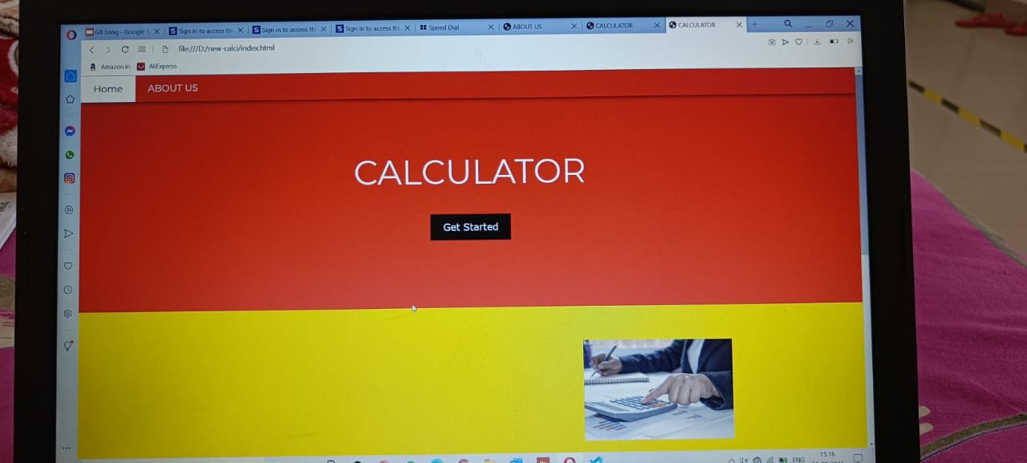

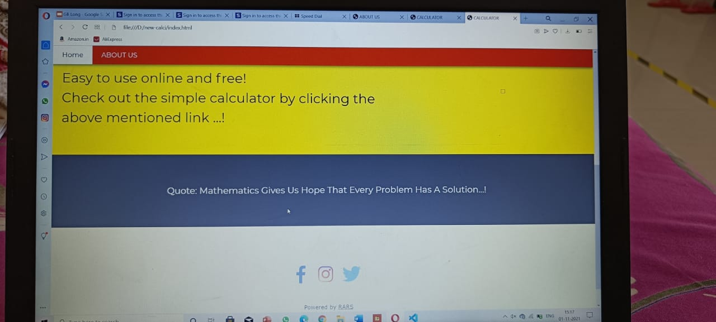

OUTPUT SCREEN ( With Question)

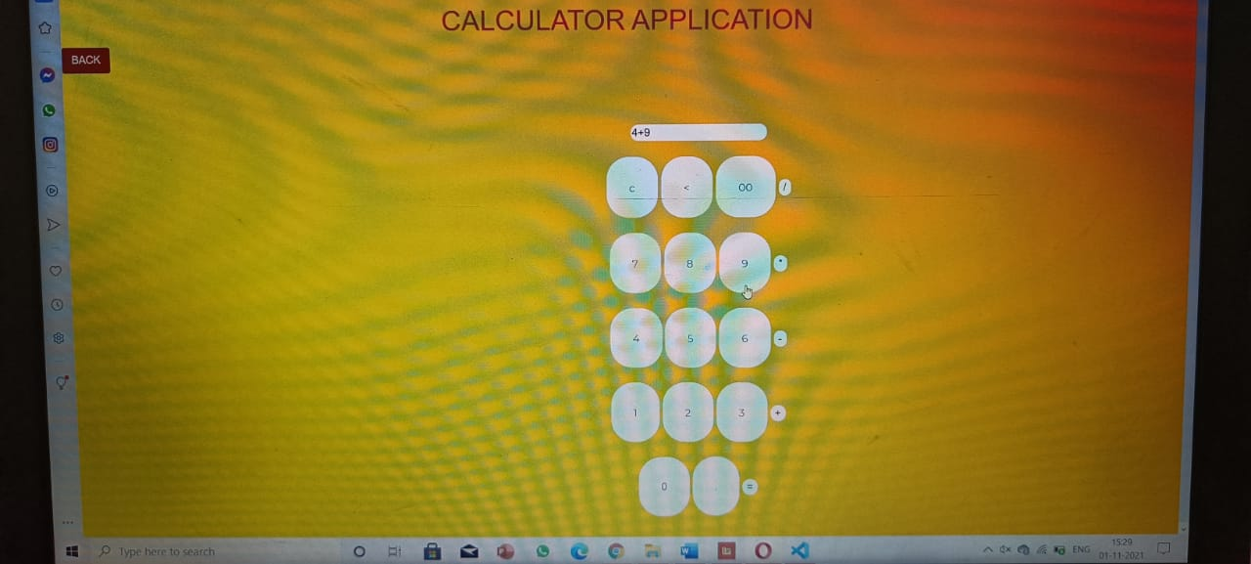

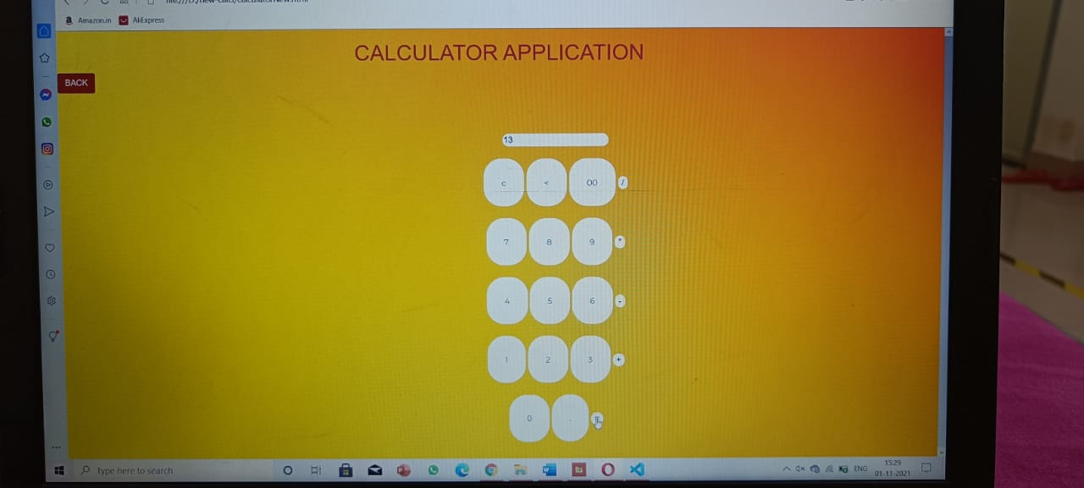

**About us….**



